CLOSE ONTARIO’S  30% GENDER PAY GAP | 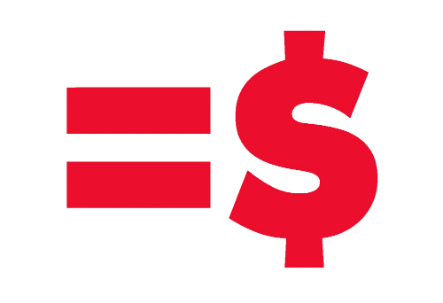
APPENDIX G
Ontario Government Commitments to Close the Gender Pay Gap
The Premier has mandated the Minister of Labour to:

Develop a Wage Gap Strategy
“Women make up an integral part of our economy and society, but on average still do not earn as much as men. You will work with the Minister Responsible for Women’s Issues and other ministers to develop a wage gap strategy that will close the gap between men and women in the context of the 21st century economy.”
The Premier has mandated the Minister Responsible for Women’s Issues to:

Promote Gender Equality in Ontario
“play a key role in ensuring that every person who identifies as a woman or a girl is able to participate as a full member of our society, exercise their rights – and enjoy their fundamental freedoms in the social, economic and civil life of our province. Your priority will be to promote gender equality in Ontario, reflecting the diversity of our communities by taking a comprehensive approach to addressing the social and economic conditions that create inequalities.”
“support the Minister of Labour in the development of a wage gap strategy… and collaborat(e) with colleagues across government to ensure that a gender lens is brought to government strategies, policies and programs.”
See equalpaycoalition.org F- /EqualPayON T. @EqualPayON

Statistics Canada. Table 202-0102 — Average female and male earnings, and female-to-male earnings ratio, by work activity, 2011 constant dollars, annual, CANSIM (database). Sorted by Ontario, all earners, average earnings, sex, female-to-male average earnings ratio. While men’s average annual earnings increased by $200 from 2010 to 2011 to $49,000, women’s decreased by $1400 to $33,600 in 2011.
Letter from Premier Kathleen Wynne to Minister of Labour Kevin Flynn dated September 25, 2014, http://www.ontario.ca/government/2014-mandate-letter-labour.
Letter from Premier Kathleen Wynne to Minister Responsible for Women’s Issues, Tracy MacCharles dated September 25, 2014, http://www.ontario.ca/government/2014-mandate-letter-womens-directorate.

